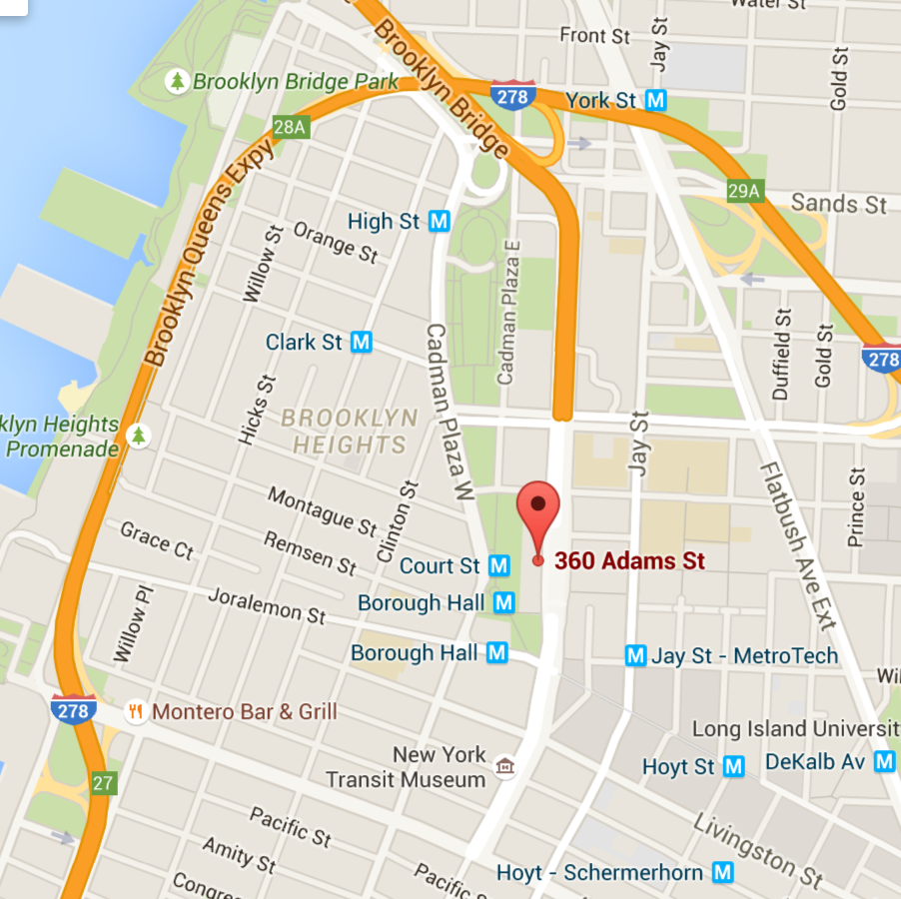 

**Under Revision**

Kings County Supreme Court  
360 Adams Street   
Brooklyn, New York 11201  
  
Open Mondays and Fridays, 11am-2pm

Assistance Center for   
the Unrepresented

🙞 🙜

#### **Fall Training**

#### Tentatively scheduled for **Monday, September 21st** 5pm – 8:30pm (includes a short break and non-pizza dinner)

#### *Additional trainings will be scheduled based on interest*

**Bar Night Fundraiser**

Come have a drink and help raise money to buy suits for pro se litigants and incarcerated indigent defendants

**Tentatively November 11th**

**Pro Bono Celebration**Make Mother’s Day cards and crafts for clients represented by Family Defense Project at the Brooklyn Defender Services

**Spring 2016**

🙞 🙜

Pro Bono Project   
  
  
  
Brooklyn Law Students for the Public Interest (BLSPI)

## Where is the ACU?

The Assistance Center for the Unrepresented is conveniently located at 360 Adams Street, in the Kings County Supreme Court – Civil Division. It’s right across the street from Brooklyn Law School!

# Upcoming Events

Assistance Center for the Unrepresented

ACU is a great way for students to get hands-on experience conducting intakes and interacting with clients. Students also learn about the myriad legal questions and issues raised by litigants in Kings County Supreme Court by assisting litigants with their court papers and legal research.

ACU is an advice-only program through which students can assist litigants who are referred by court personnel and library staff. Students will perform intakes, inform the litigants of the scope of the program, and have litigants complete the limited scope agreement.

Depending on the nature and complexity of each individual’s questions or issues, some litigants will be referred to law students who will assist the litigant in filling out court forms, finding appropriate resources on Law Help, and/or referring the litigants to other programs where applicable. Litigants with more or less complex issues will be referred to a Law Help self-help terminal or supervising attorney.

Students who volunteer with the ACU are also invited to participate in various BLS community events. This fall we will be hosting a fundraiser to help buy suits for pro se litigants who cannot afford legal counsel. In the spring semester, we will partner with Brooklyn Defender Services to provide Mother’s day cards, crafts, and encouragement to clients of the Family Defense Project.

Pro bono involvement with the ACU is a great way to reinforce the basics of civil procedure, learn the more practical aspects of legal practice, interact with clients in a professional setting, and serve your Brooklyn community!

# Get involved! Learn practical skills! Make a difference!

**Q: Why volunteer with ACU?**

**A:** ACU offers hands-on, direct client experience. You can help low-income individuals navigate the court system, while learning about different areas of civil law that affect the Brooklyn community!

**Q: What kinds of cases do students generally encounter at the ACU?**

**A:** The majority of cases handled at the ACU are matrimonial and housing related. Sometimes litigants are seeking to challenge a decision made by a NY state or city agency, such as NYCHA.

**Q:** **How much time do I need to commit to volunteer with ACU?**

**A:** The time commitment is incredibly flexible and students make their own schedule by signing up for shifts online! The ACU is open on Mondays and Fridays from 12 - 2 pm.

**Q: How do I get involved?**

**A:** E-mail [probono@blspi.org](mailto:probono@blspi.org) to join our mailing list or ask for more information!

## Q&A